

Internet of things PROJECTS/INTERNSHIP

# College Name

* ****SRM Institute of Science and Technology.****

# Company Name

* ****Vyorius.****

# Domain

* ****Internet of things.****

### Internship Project topics

1. **Automatic Room Temperature Controller**
2. **Voice Control Home Automation**

1.Voice control home automation

Software's In detail



Adafruit.io is a cloud service - that just means we run it for you and you don't have to manage it. You can connect to it over the Internet. It's meant primarily for storing and then retrieving data but it can do a lot more than just that!



IFTTT allows you to do more with over 700 different apps and services, including Twitter, Dropbox, Evernote, Fitbit, Amazon Alexa, and Google Assistant. We bring services together into Applets, automations that allow you to do things your apps and devices can't do on their own.

**Procedure**

Open Adafruit io in google, create an account and go to IO and create a dashboard there.

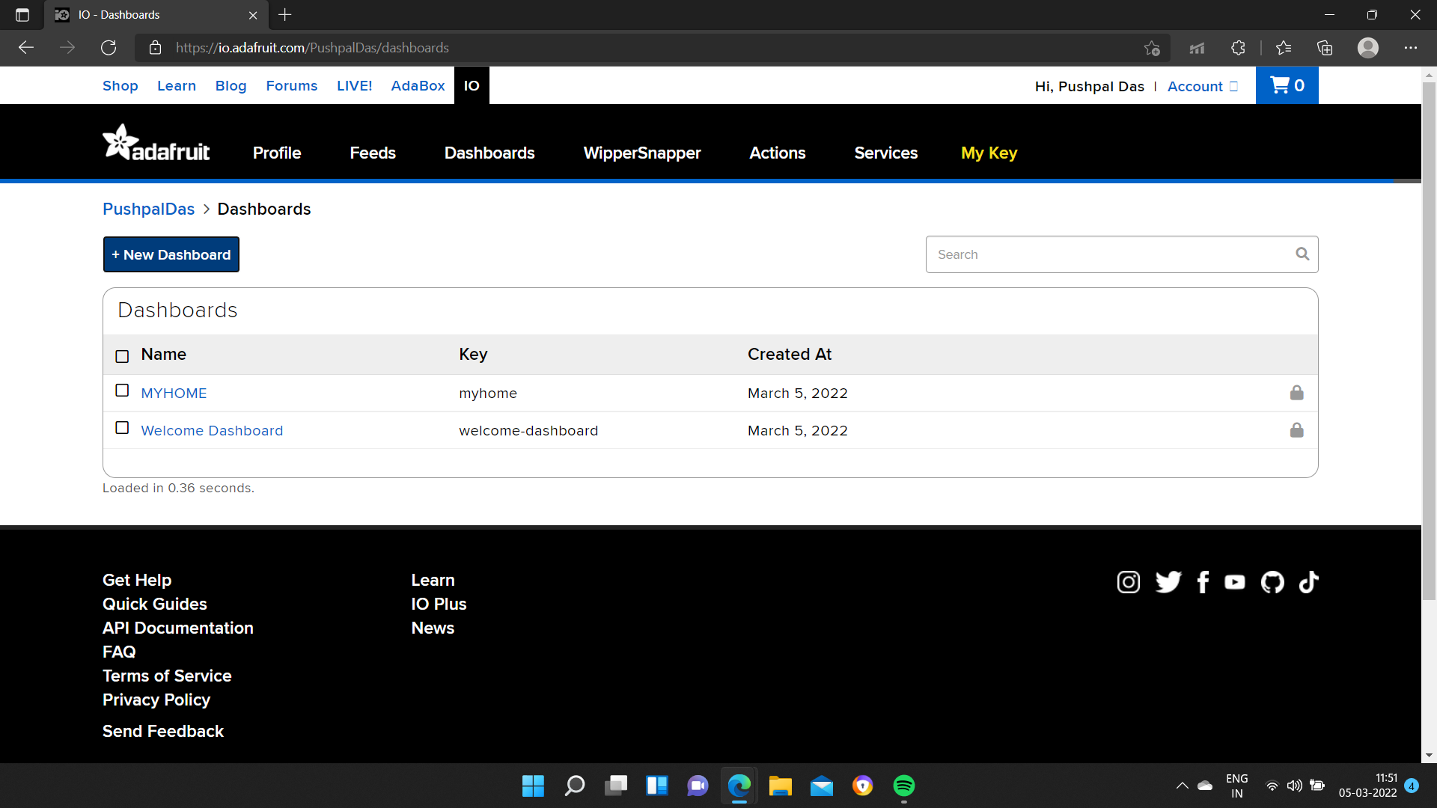

Create new block

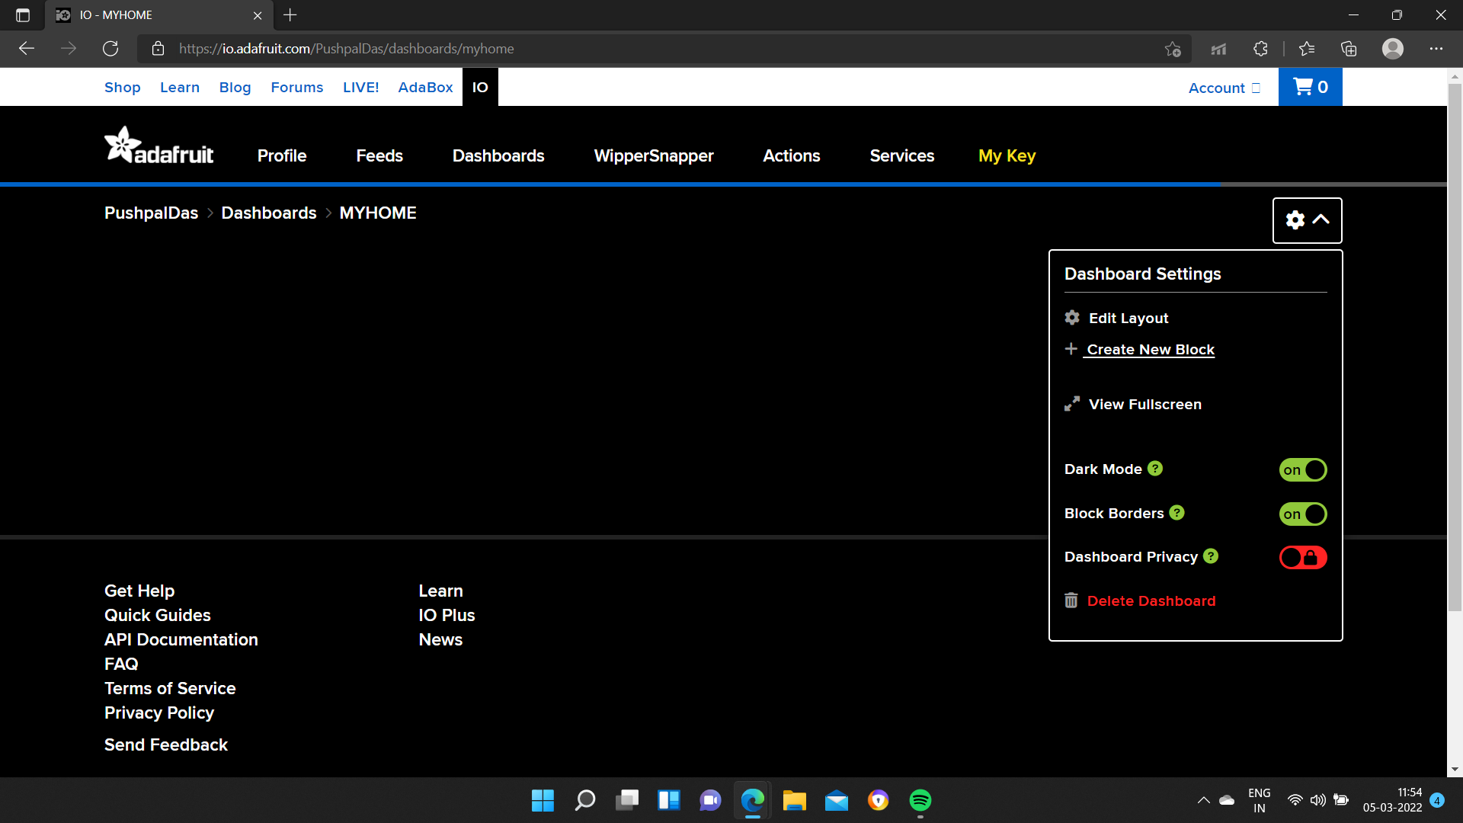

Chose indicator

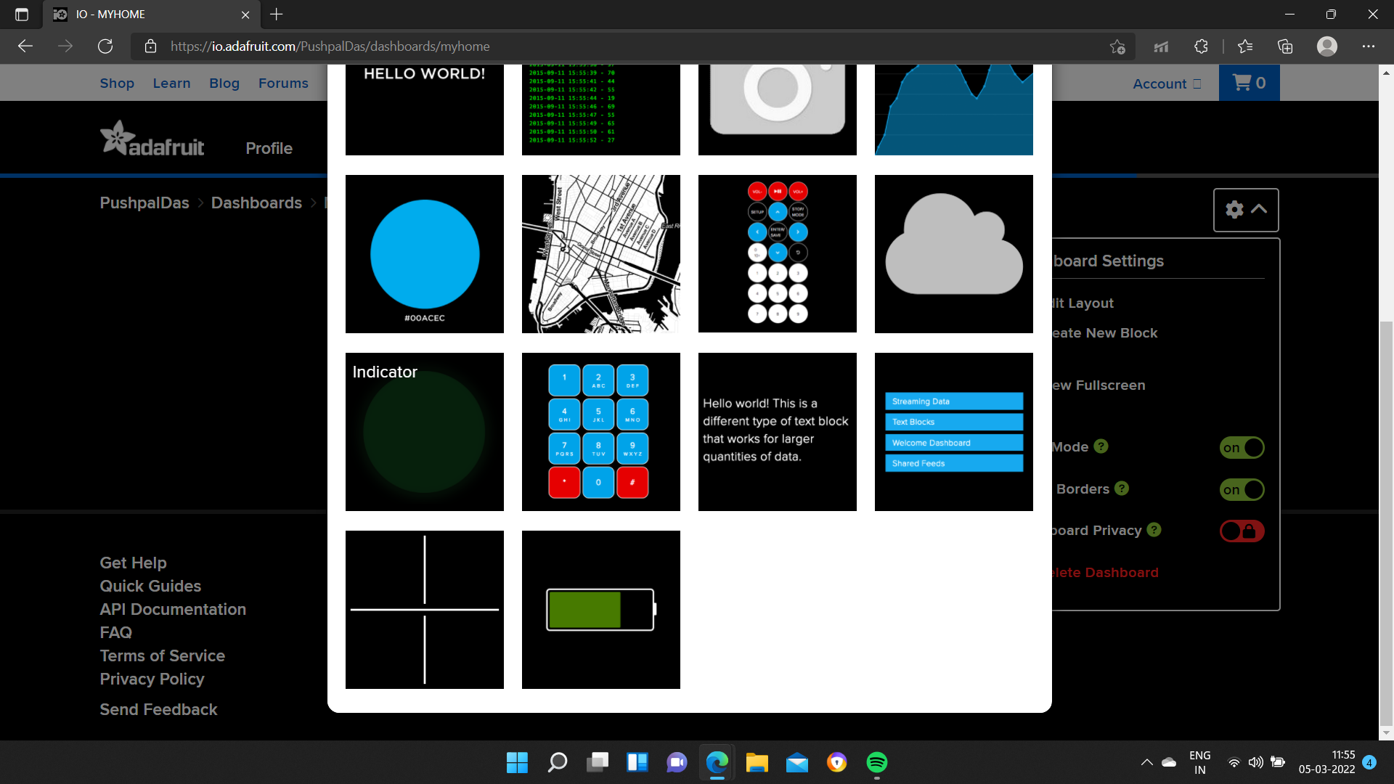

Create a feed and select on next steps

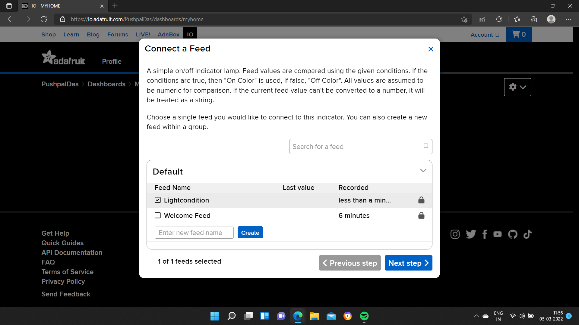

Give a name to the block

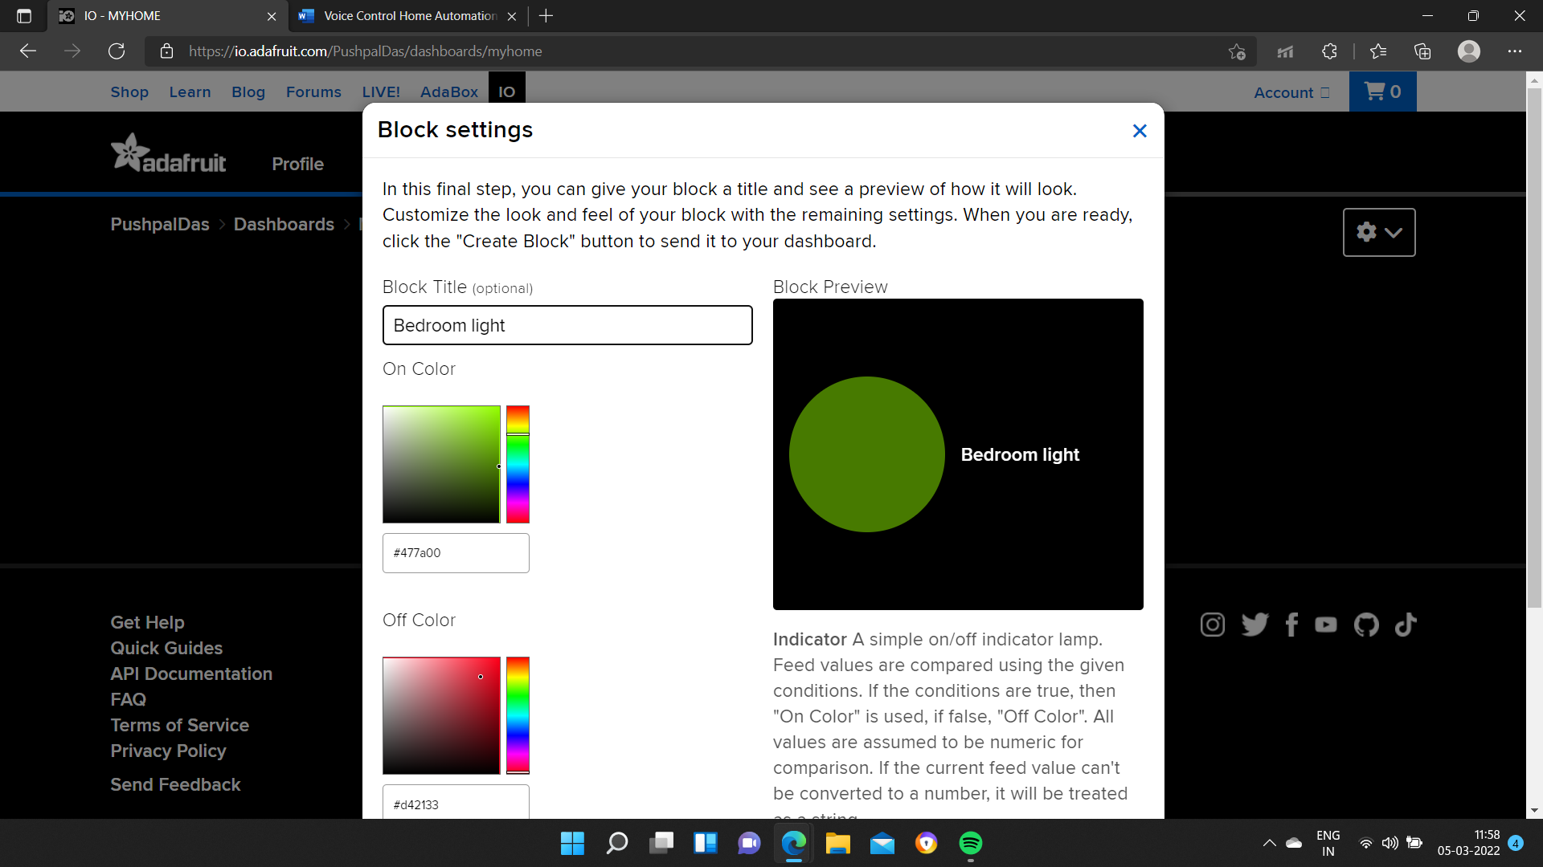

Create the block after assigning the condition properly

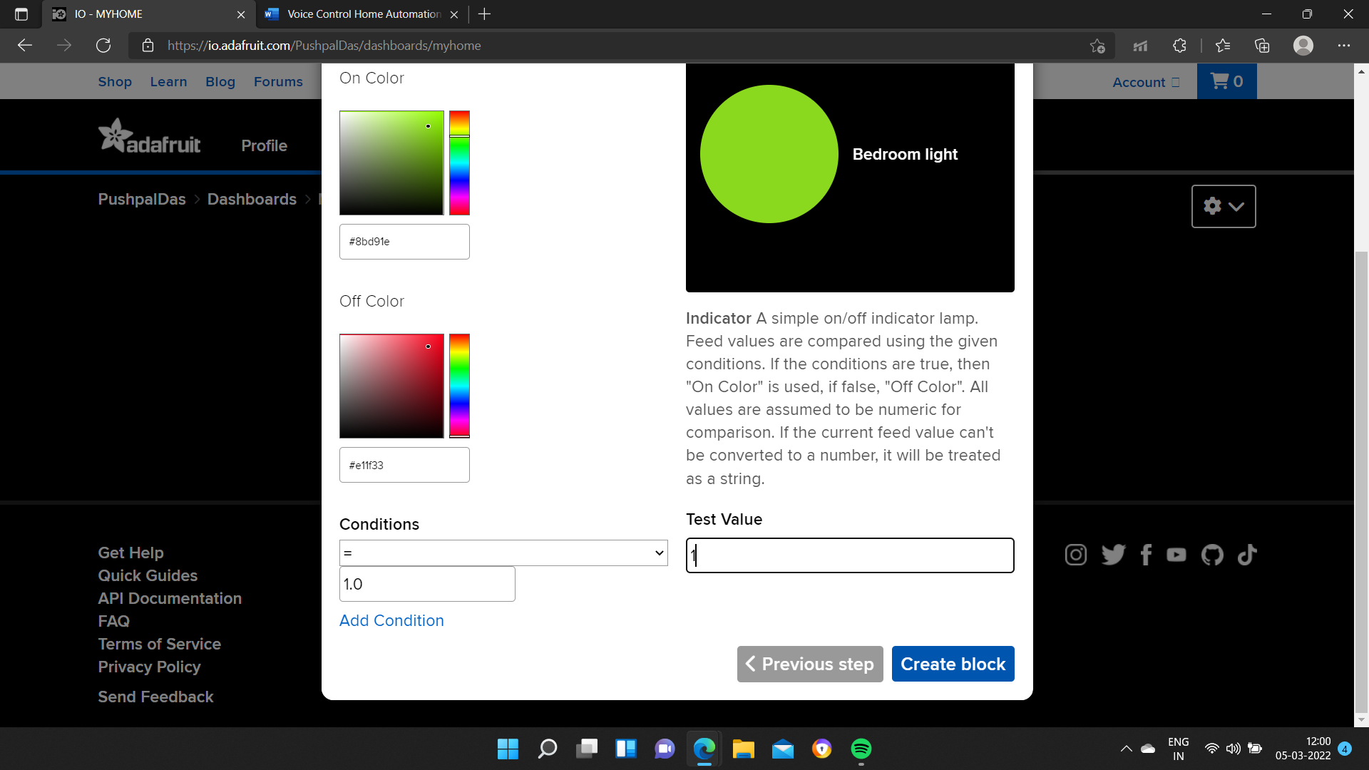

Thereby we successfully created our dashboard.

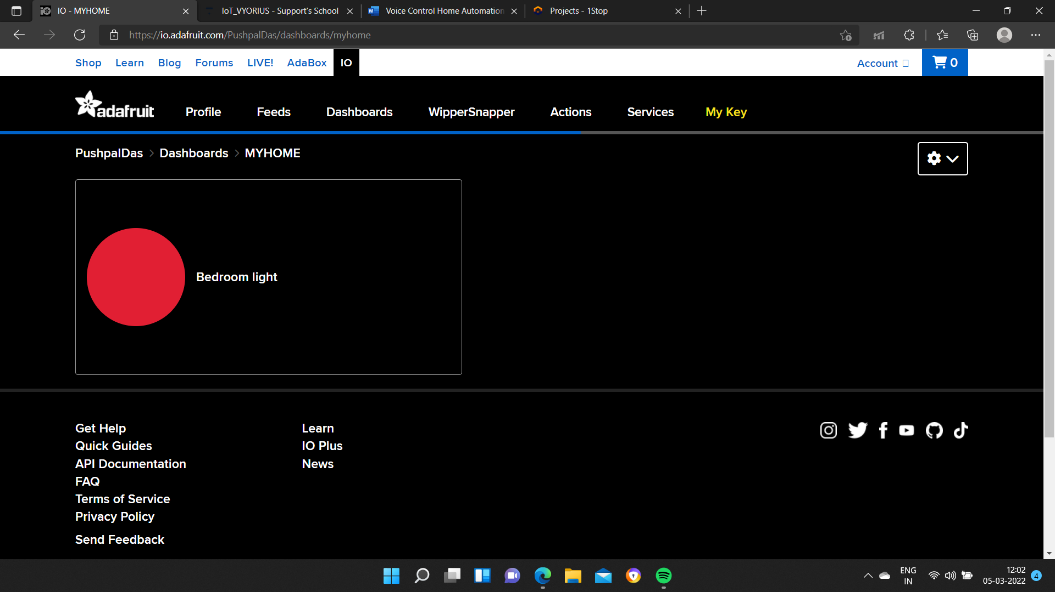

Google IFTTT and login to get started

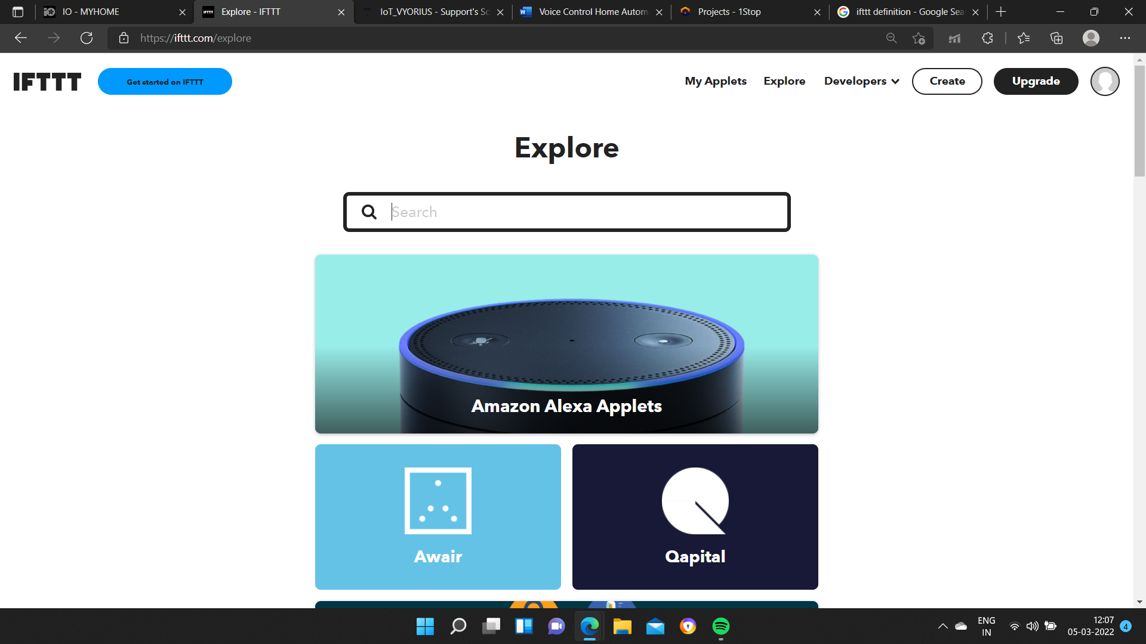Go to My Applets and click on Create

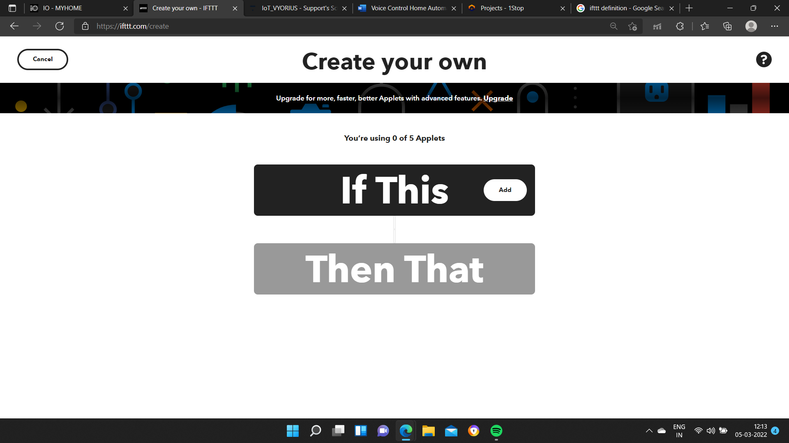Choose the service as Google assistance

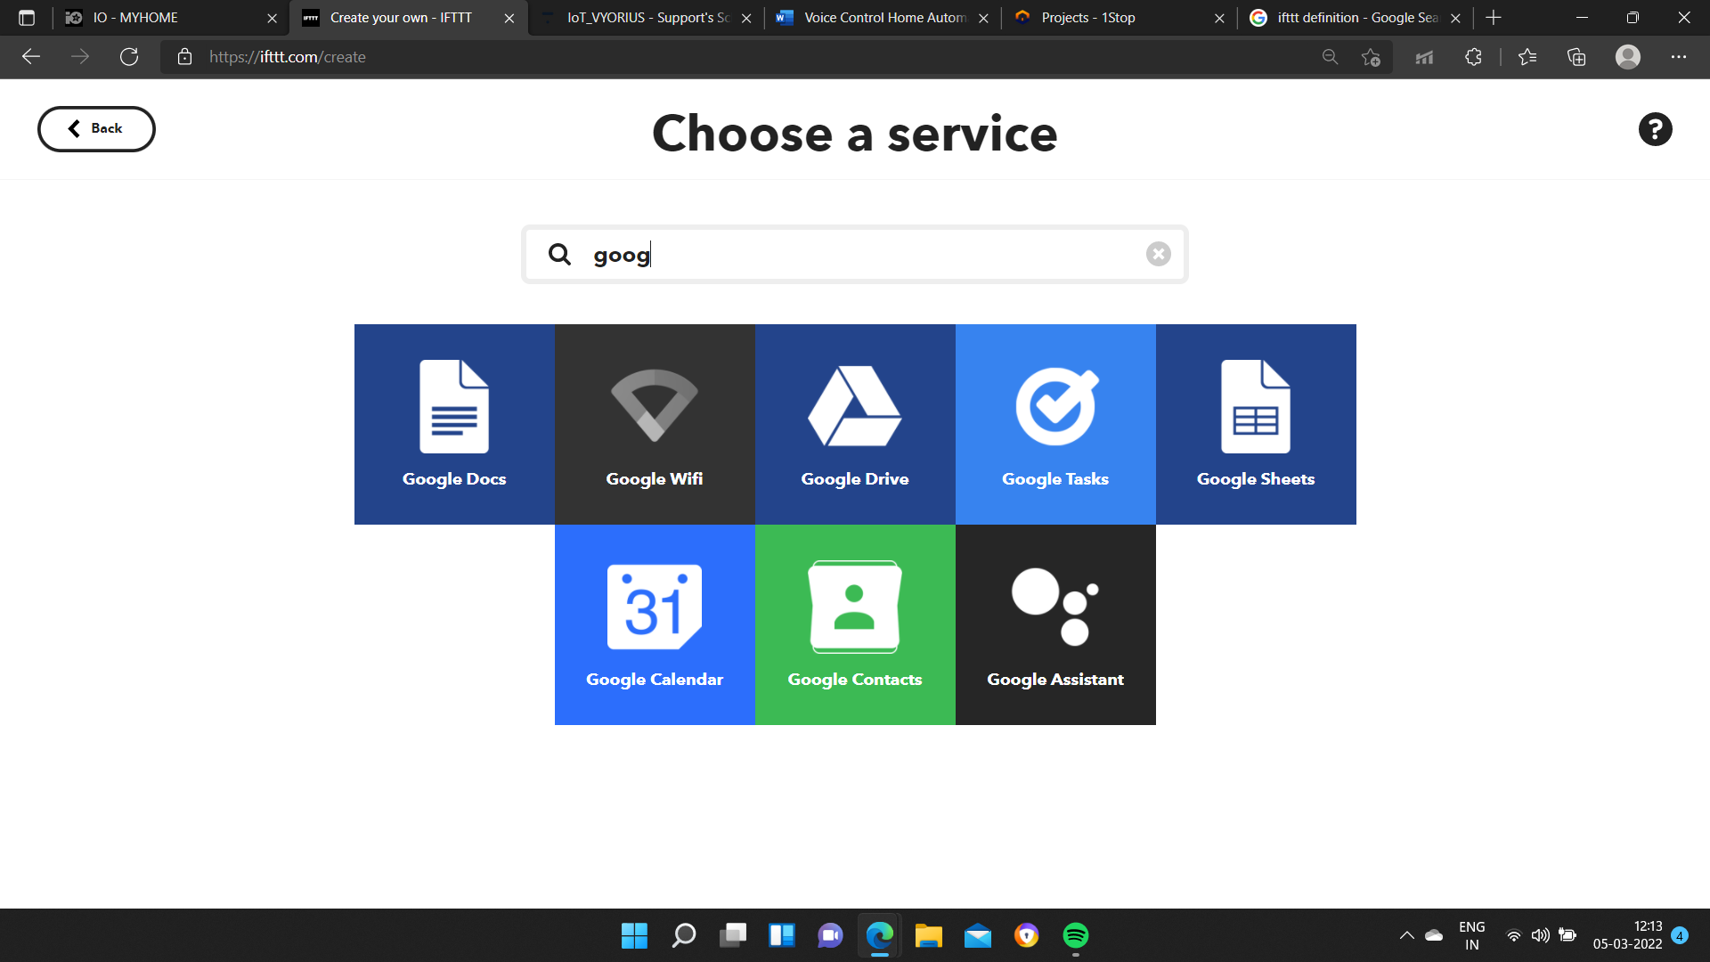Chose the trigger as the first one

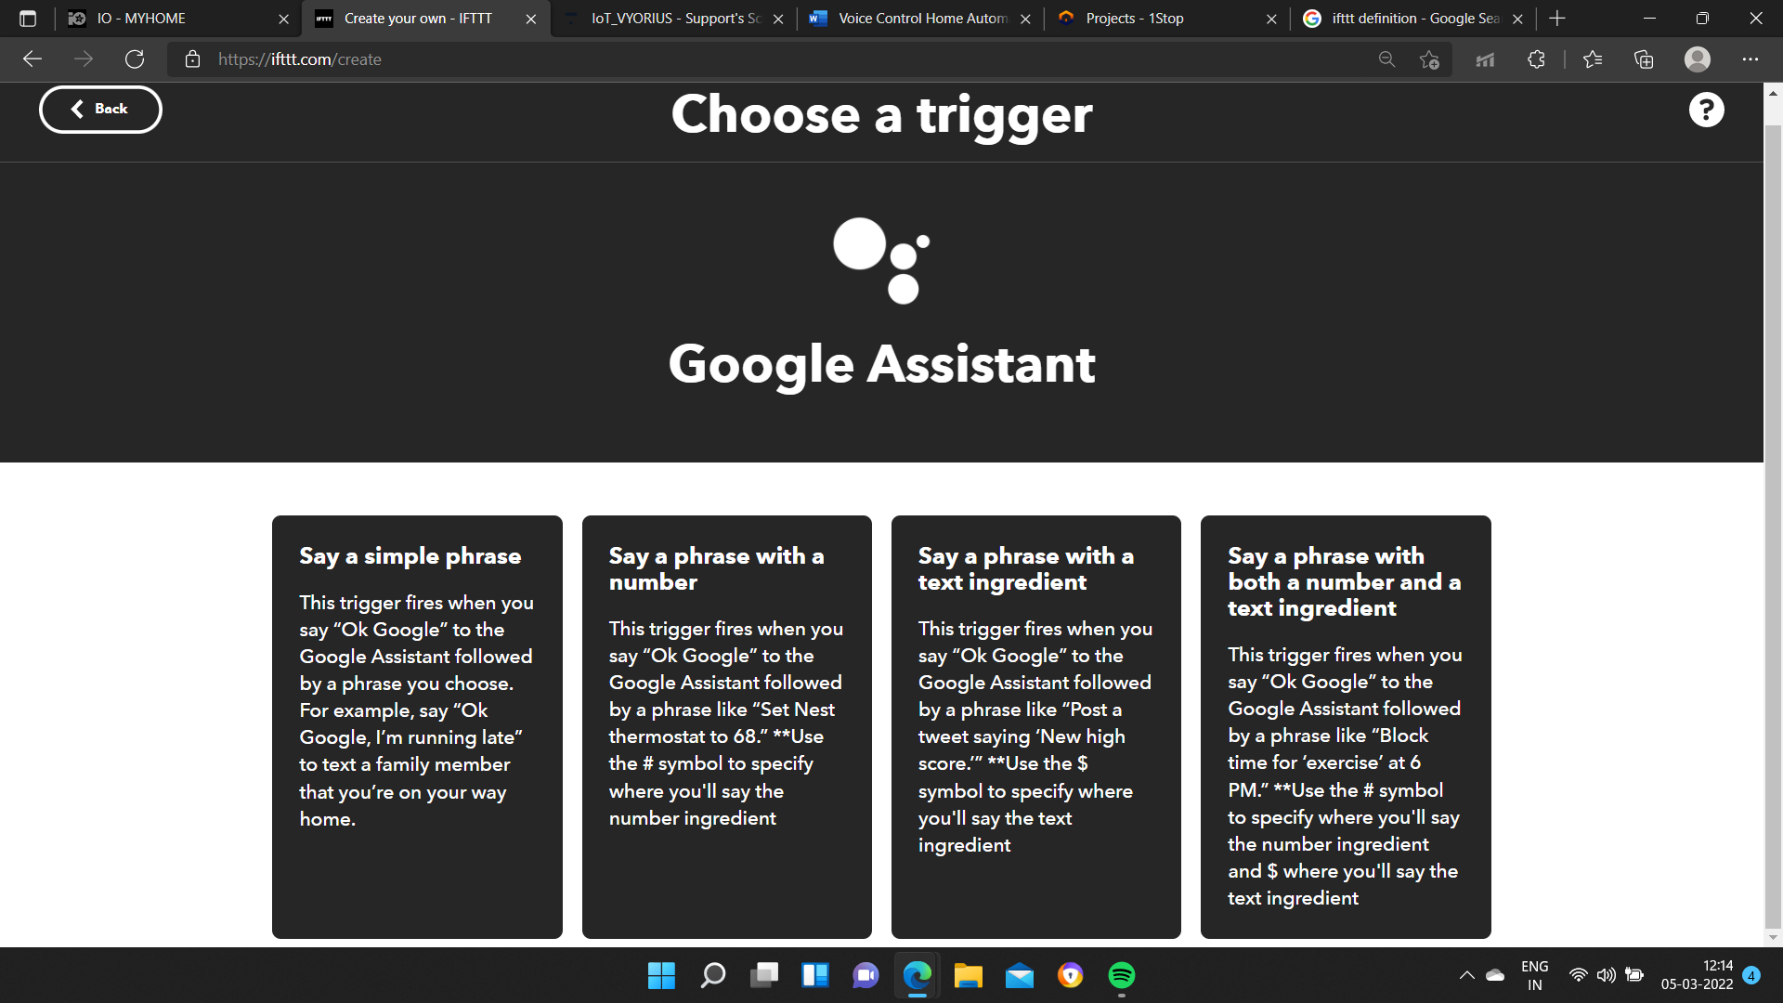After connection with your google account, create a trigger

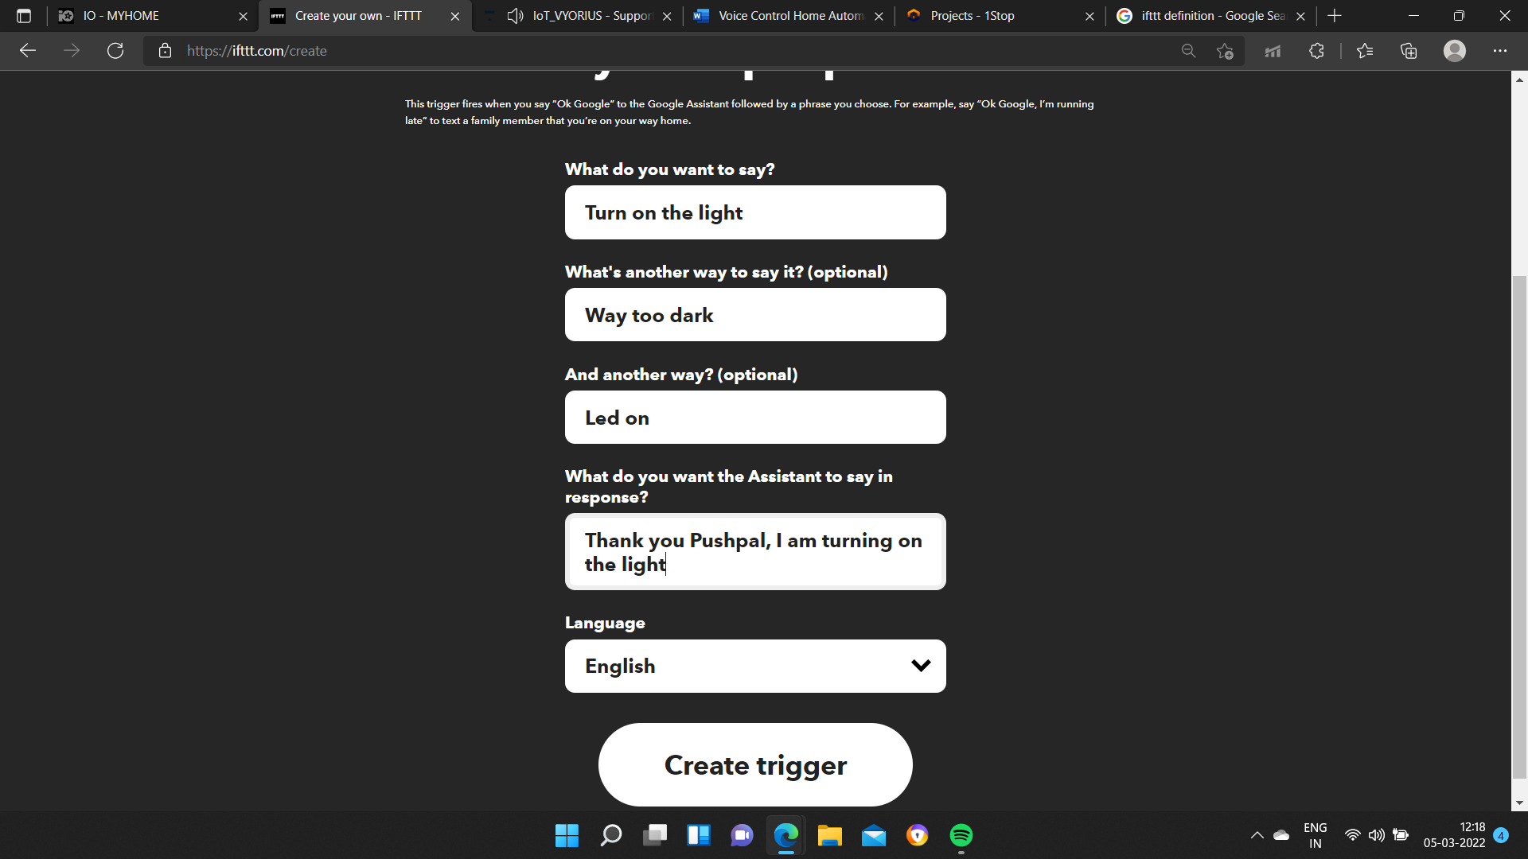After creating the trigger chose on THEN THAT, and chose the service as Adafruit

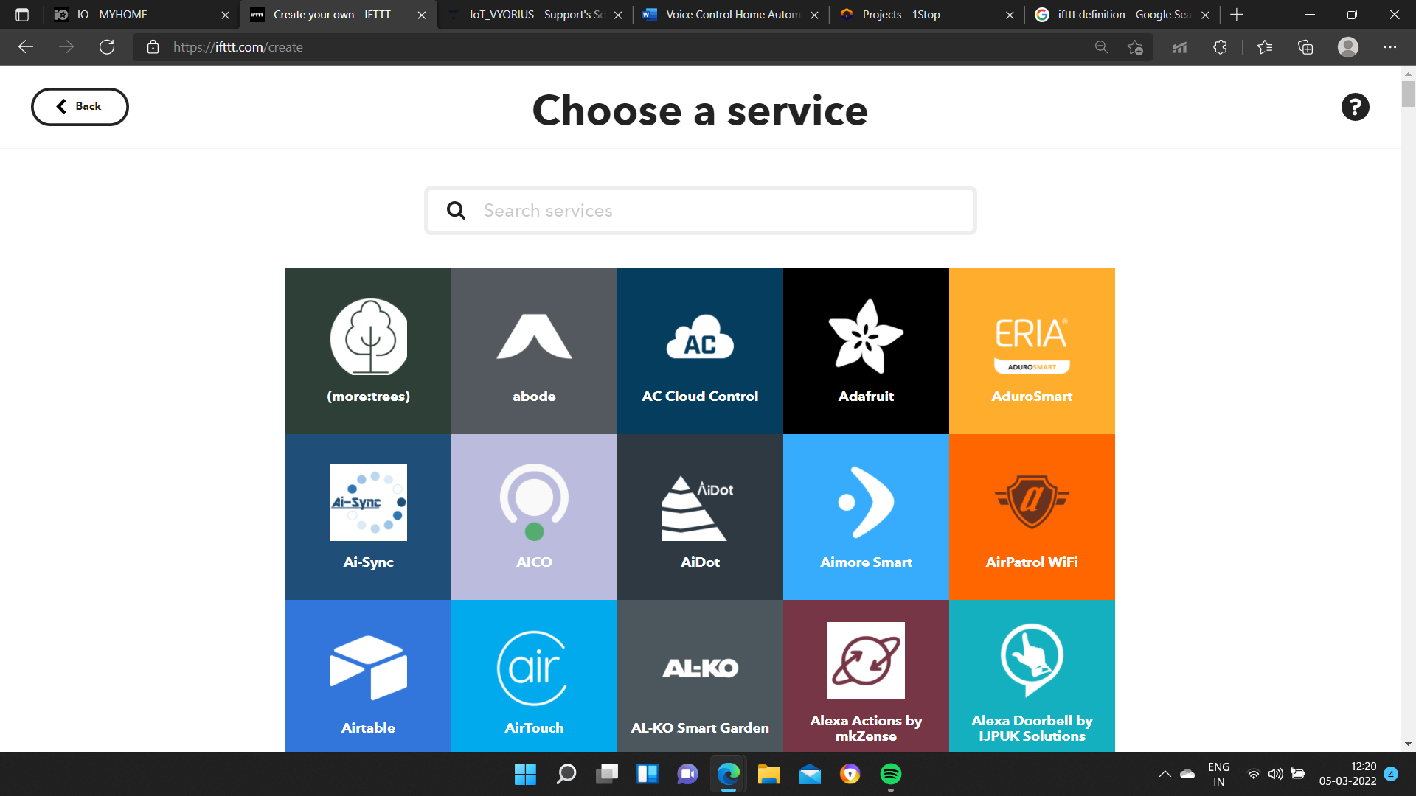

Send the data

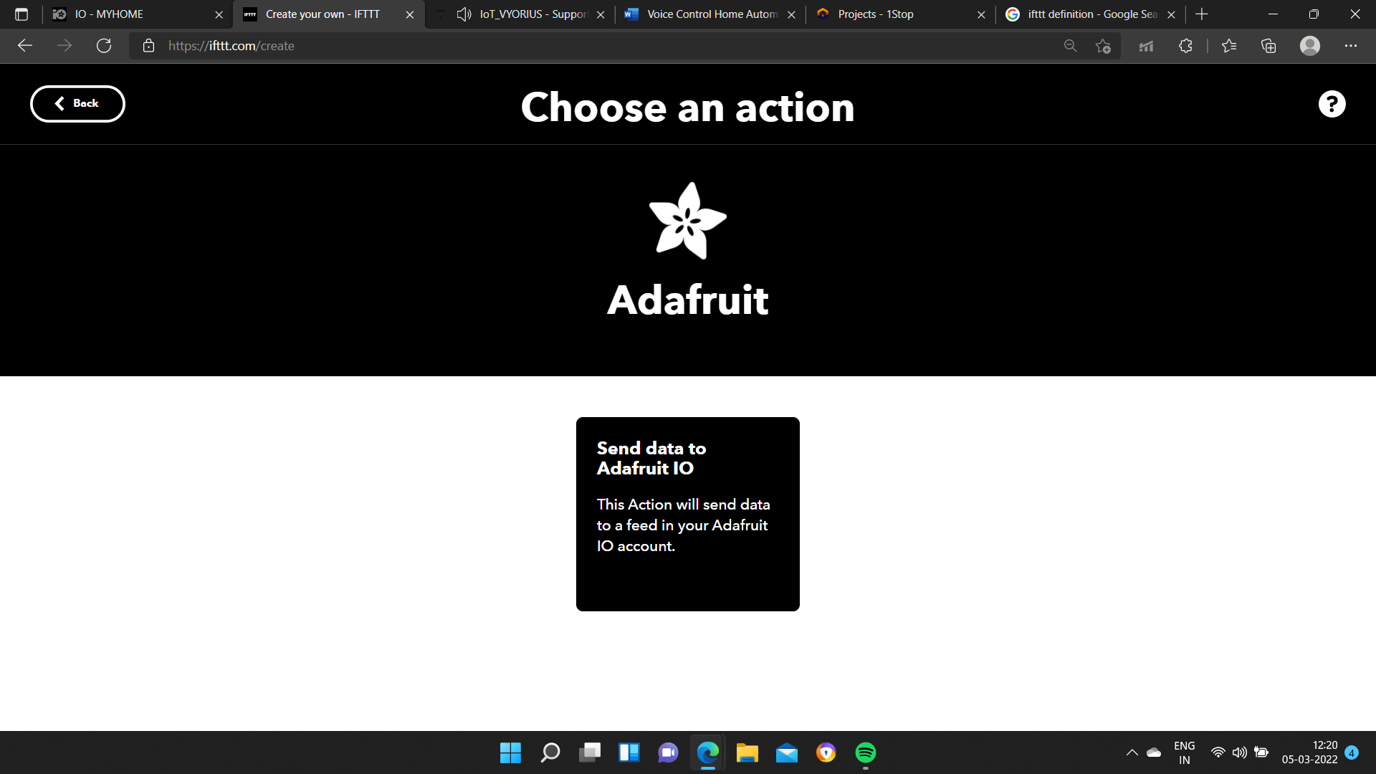

Connect

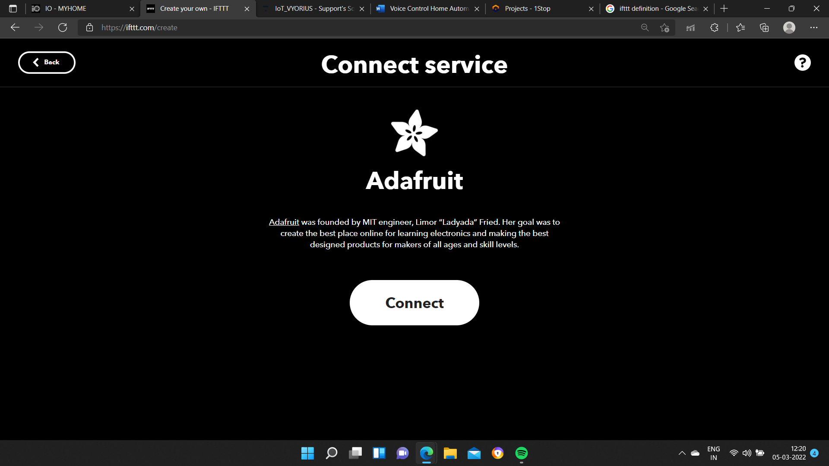Select the feed name and data to be send

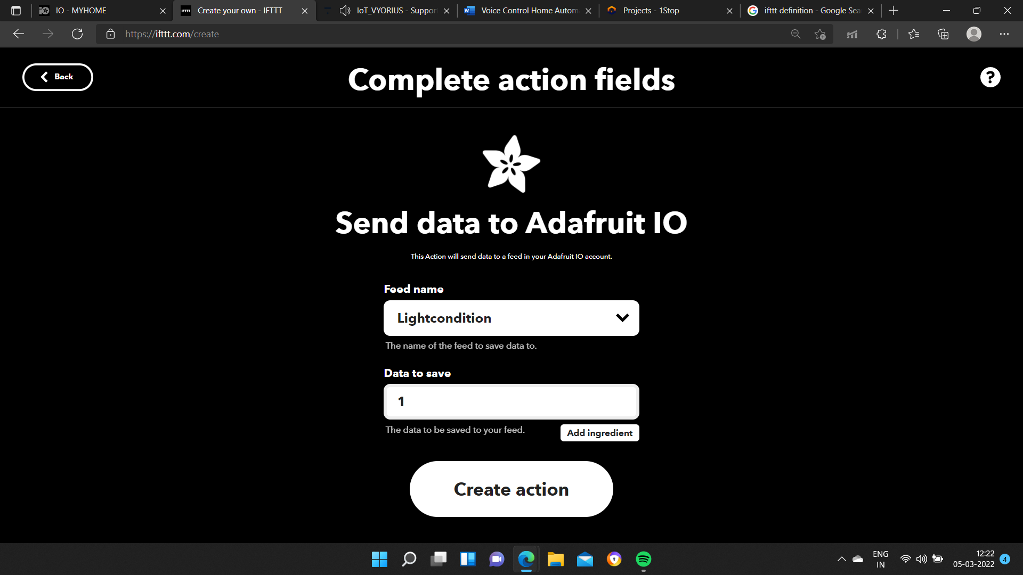Same way creates another trigger for turning off the light and finish off with another applet

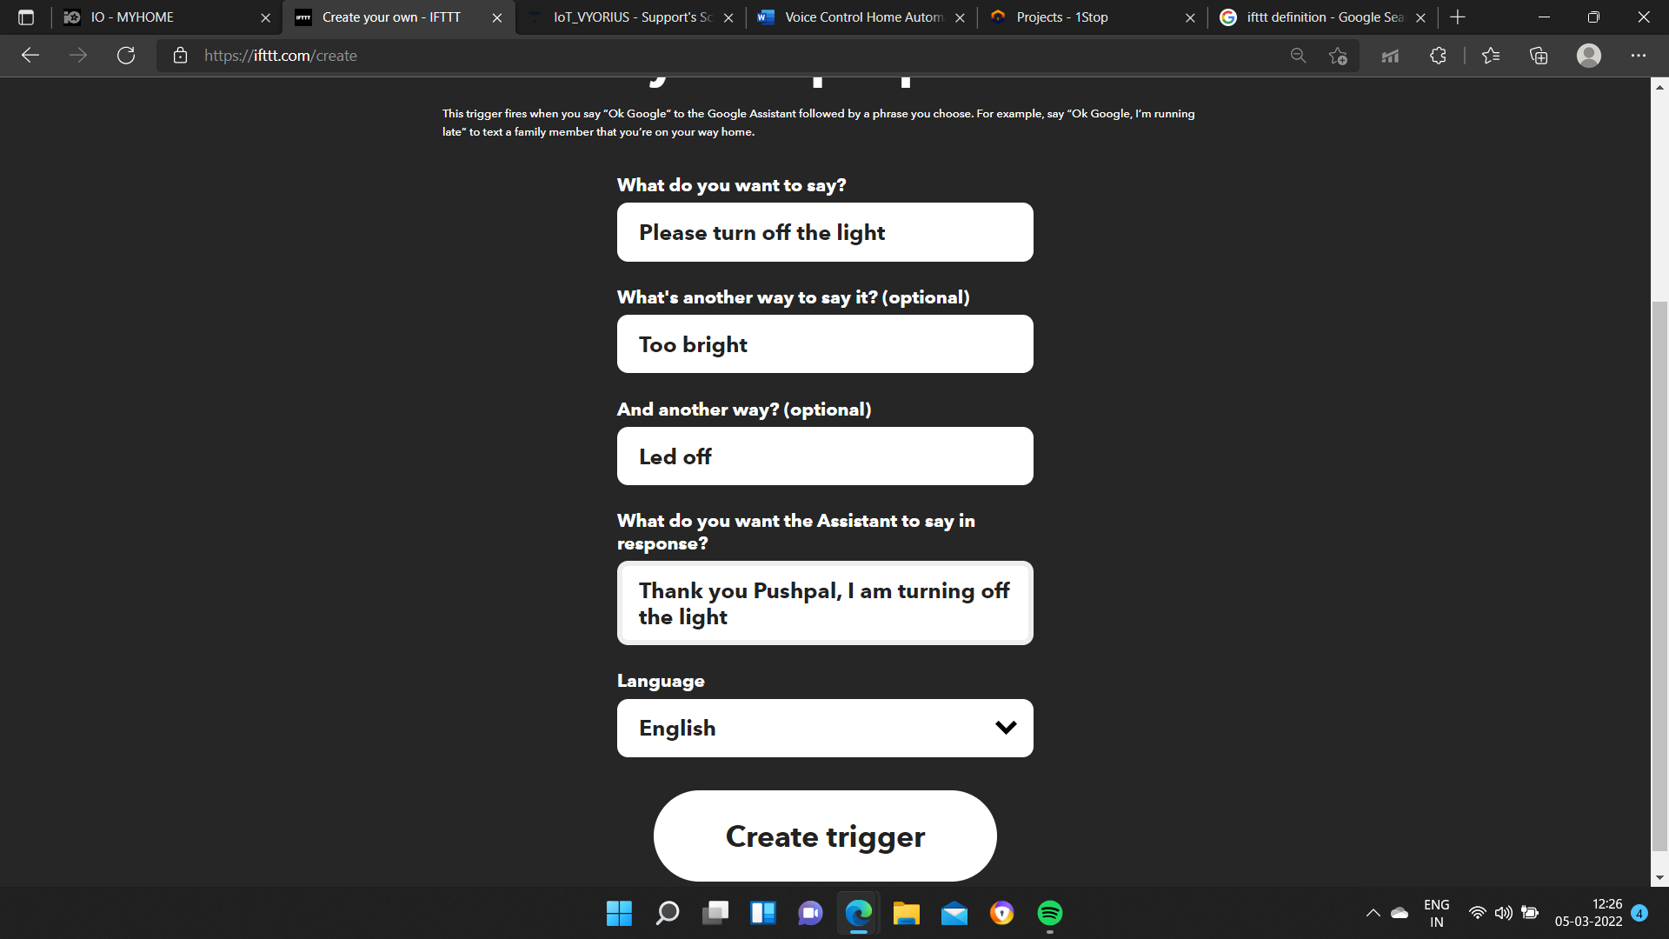So now we have two applets for turning on and off the light as we can see,

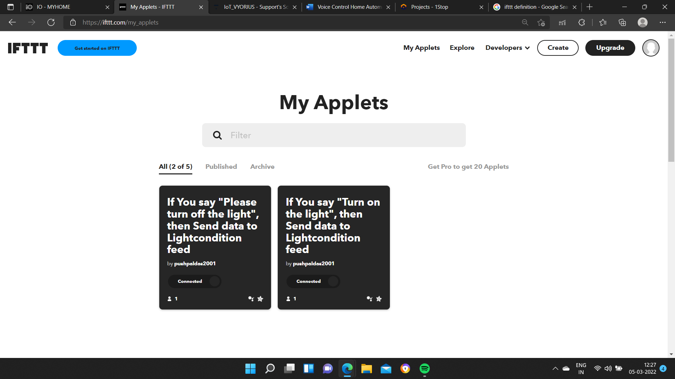

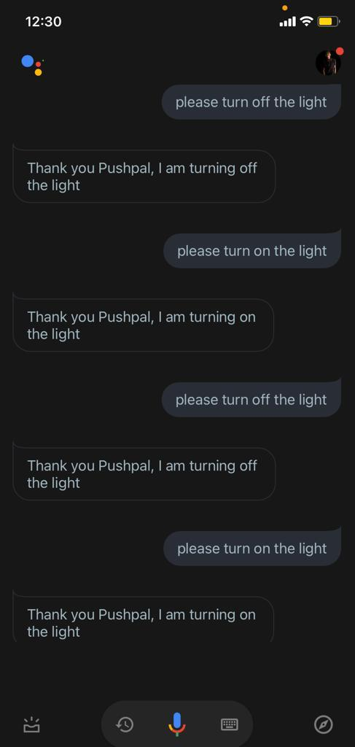

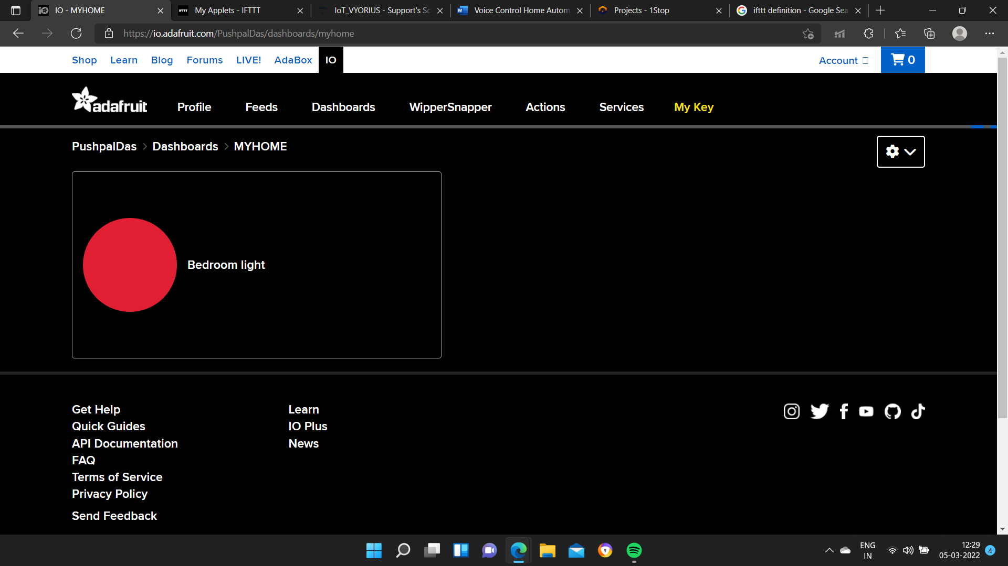

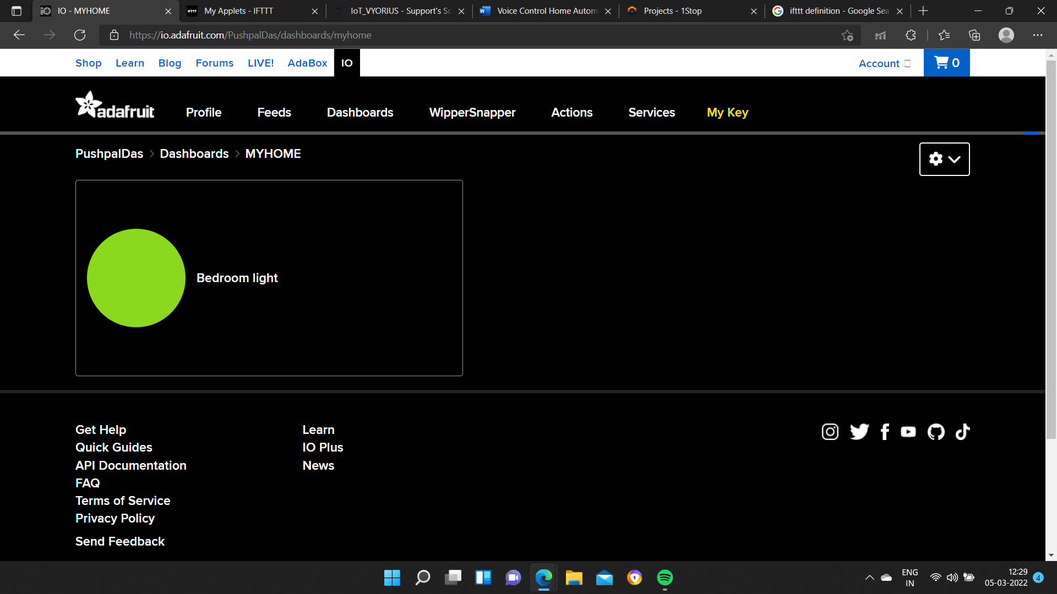**Conclusion**

Voice Based Home Automation System is a project for the handicap and old peoples. In this project every possible group is taken into consideration like light, fan, etc. Based on this group there are different commands and that commands are used to trigger that particular device either ON or OFF. It reduces the consumption of energy as the devices are controlled by voice and if the user forgets to turn of the device SMS is send to remind the user about turning OFF the device.